South Gloucestershire remains a safe place to live and work, although there have been a number of high-profile tragic incidents in the past year which have had an impact on our young people and the wider community, and understandably have caused concern among parents and carers as well as residents.
We want to reassure you that the council is working together with our partners and alongside our communities to tackle the root causes of knife crime and serious violence. South Gloucestershire Violence Reduction Partnership, which includes the council’s community safety team, children’s social care, police, schools and other partners, is committed to educating young people about the dangers and impacts of knife crime and is working hard to keep them safe.
The partnership commissions educational workshops and interactive sessions in schools, referrals to work-based training and sports courses, training for professionals and outreach youth work. Wider community support includes the installation of bleed kits to help victims of trauma incidents, taking part in police operations and promoting knife amnesties and surrender bins, and creating resources to share with education settings, parents and the wider community including a guide on starting conversations about knife crime.
To help support our young people, their parents and carers and the wider community, it is essential that we all provide correct, consistent information and signposting. Help us share information and resources to communities in South Gloucestershire using the below suggested social media posts and images. Content for websites and newsletters can also be found below.
If you require any further information or help using this toolkit please contact Alexandra.Dent@southglos.gov.uk
If you have any questions about tackling serious violence in South Gloucestershire please contact CommunitySafetyTeam@southglos.gov.uk
Further information and support on what we are doing to tackle knife crime and serious violence is available on our website https://beta.southglos.gov.uk/violence-reduction-partnership/

Social media images and suggested copy

Knife crime guide for parents and carers
Facebook
Text: Whatever the reason a young person is involved in knife crime, it is likely to have something to do with fear.
The council, through the #SouthGlos Violence Reduction Partnership, has worked with the Ben Kinsella Trust to reproduce a guide for parents and carers to help them speak to their child about knife crime and the risks and devastating consequences of carrying a weapon.
The booklet can be viewed or downloaded here: https://beta.southglos.gov.uk/static/e8a46bda01bf0a700ffb6fe7b7e168fd/Knife-crime-guide.pdf

X (formerly Twitter)
Text:
One of the reasons people carry a knife is fear.
Read this guide for help speaking to young people about knife crime, the risks and consequences: https://beta.southglos.gov.uk/static/e8a46bda01bf0a700ffb6fe7b7e168fd/Knife-crime-guide.pdf

Image:
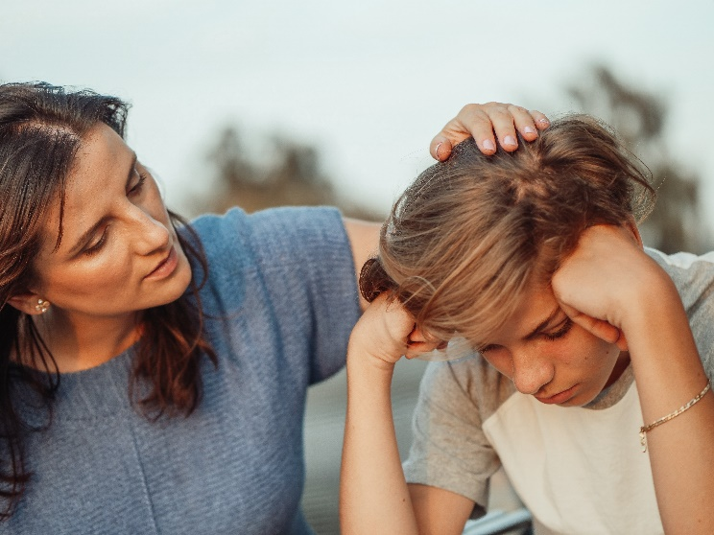

Bleed kits
Facebook
Text: Did you know life-saving bleed kits are located across #SouthGlos?
Kits are installed alongside existing HeartSafe defibrillators, and in other community locations, and include dressings, tourniquets, gloves and a guide to help manage bleeds. They can be used for any catastrophic bleed including traffic collisions, falls, or other traumatic injuries.
In an emergency always call 999 and ask for the ambulance service.
Find out where bleed kits are located in #SouthGlos https://www.heartsafe.org.uk/bleed-kit-map/

X (formerly Twitter)
Text: Did you know life-saving bleed kits are located across #SouthGlos? Kits are installed alongside defibrillators, and in other community locations, and include dressings, tourniquets and gloves. Find out where they are https://www.heartsafe.org.uk/bleed-kit-map/

Image:
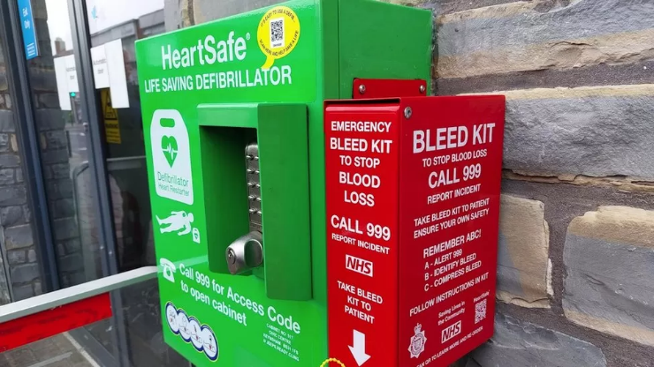

Surrender bins
Facebook
Text: South Gloucestershire is a safe place to live and work but incidents of serious violence do occur.
Did you know knife amnesty bins are located in Patchway, Kingswood and Staple Hill? Any bladed article can be wrapped and put inside without question or fear of prosecution.
In an emergency call 999. To anonymously report a crime visit https://crimestoppers-uk.org/

X (formerly Twitter)
Text: Knife amnesty bins are located in Patchway, Staple Hill and Kingswood. Any bladed weapon can be placed inside without question or fear of prosecution.
In an emergency call 999. Anonymously report a crime https://crimestoppers-uk.org/

Image:
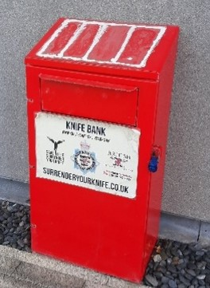

Fearless
Facebook
Text: 9 out of 10 young people who go to A&E with a knife wound have been stabbed by their own weapon.
Help change that statistic and encourage young people to report criminal activity, and people who they know carry knives.
Fearless is completely anonymous and is a dedicated service for young people www.fearless.org

X (formerly Twitter)
Text: Help stop young people carrying knives. Encourage them to report crimes and find out the dangers of carrying a knife at https://crimestoppers-uk.org/fearless/more-info/crime-types-explained/knife-crime

Image:
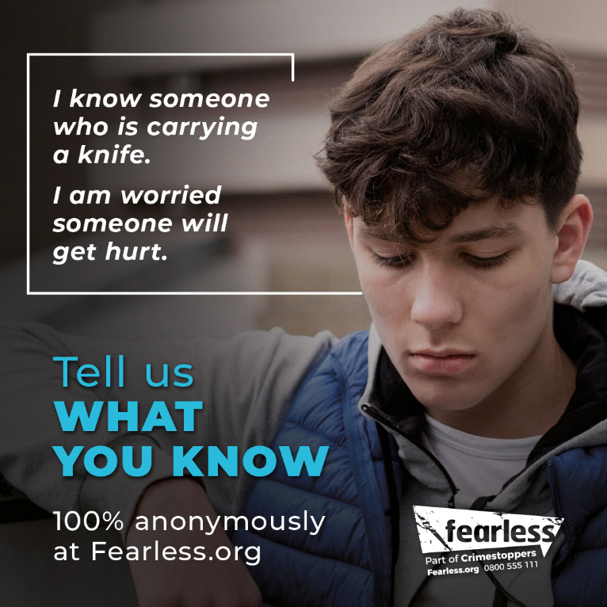

Blunt Truth
Facebook
Text: The #SouthGlos Violence Reduction Partnership is continuing to fund workshops in schools about the dangers of carrying a weapon.
During a recent session at Chipping Sodbury School, students discussed the devastating impacts of knife crime with doctors and police and were taught life-saving First Aid skills by volunteers from the Great Western Air Ambulance Charity.
Further information about the work being done to support young people is available here https://beta.southglos.gov.uk/violence-reduction-partnership/

X (formerly Twitter)
Text: The #SouthGlos Violence Reduction Partnership funds workshops about the dangers of carrying weapons, like this one at Chipping Sodbury School recently.
Further info https://beta.southglos.gov.uk/violence-reduction-partnership/

Image:

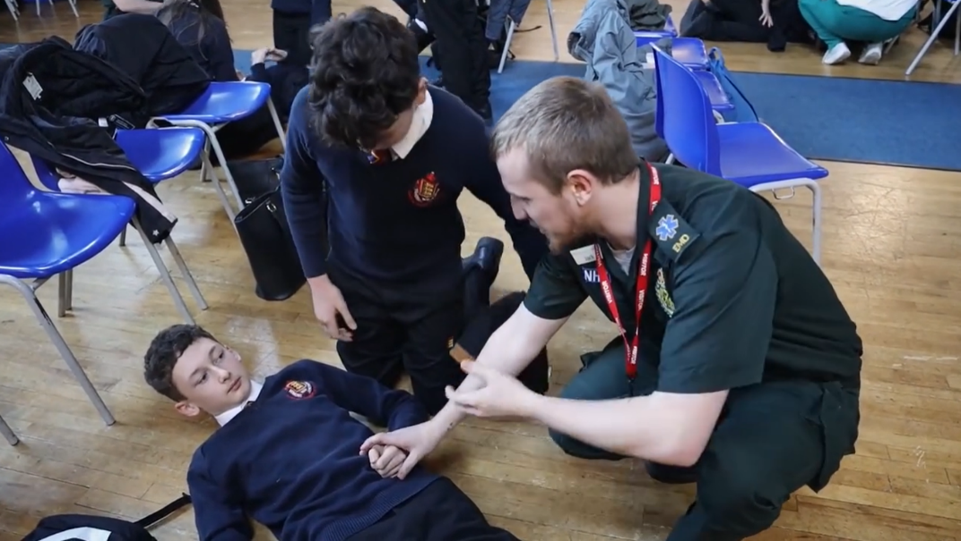

Website copy

South Gloucestershire is a safe place to live and work but incidents of serious violence do occur.
Knife crime in particular has a devastating impact on communities and individuals. South Gloucestershire’s Violence Reduction Partnership, which includes the council’s community safety team, children’s social care, police, schools and other partners, is committed to educating young people about the dangers and impacts of knife crime and is working hard to keep them safe.
In South Gloucestershire, there are also a number of bleed kits which can be used to help save lives in catastrophic trauma incidents and a number of knife surrender bins, where people can place knives and bladed weapons without question or fear of prosecution.
Find out more about the work being done to combat knife crime, and access resources, at https://beta.southglos.gov.uk/violence-reduction-partnership/

Newsletter copy

South Gloucestershire remains a safe place to live and work, although a number of incidents of serious violence have had a lasting impact on young people and understandably caused concern in communities.
South Gloucestershire’s Violence Reduction Partnership, which includes the council’s community safety team, children’s social care, police, schools and other partners, is committed to educating young people about the dangers and impacts of knife crime and is working hard to keep them safe. The partnership funds early intervention programmes and support measures to stop incidents of violence and prevent future crimes. It also provides resources to help parents and carers talk to young people about knife crime and how to access support.
Find out more about what is being done to tackle knife crime in #SouthGlos at https://beta.southglos.gov.uk/violence-reduction-partnership/

Contact information
Alexandra Dent
Communications Account Lead
Strategic Communications
Alexandra.Dent@southglos.gov.uk
www.southglos.gov.uk

